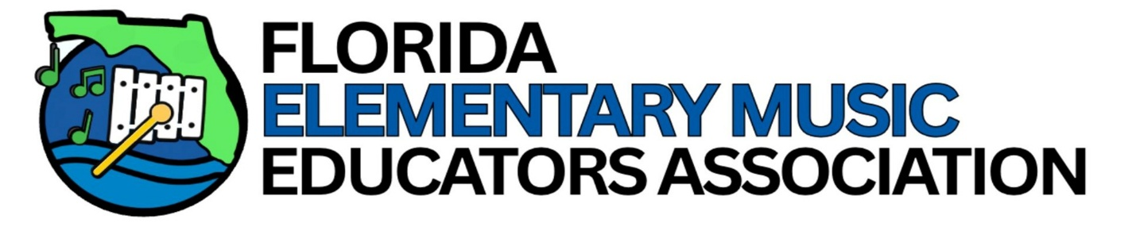
FLORIDA ELEMENTARY MUSIC EDUCATORS ASSOCIATION
FEMEA Rising STARS Workshop
Get Ready for Your Student to SHINE BRIGHT!
Dear Parent or Guardian:
Congratulations to your Rising Star!
We extend a big CONGRATULATIONS to all the amazing 3rd-grade students and their incredible teachers across the state who have been selected for this year's Rising Stars Workshop! Their hard work, passion, and dedication are inspiring, and we cannot wait to see that shine through a day full of energy, music, and joy. We hope this experience creates beautiful, lasting musical memories for all. A FEMEA Rising Stars Checklist is included with this letter to help you make the necessary arrangements for your child.
Important Information
- You must register your child for Rising Stars online at www.femeamember.org by November 6, 2026.
- Registration fees can also be paid through the registration portal.
- A parent or guardian other than the music educator is required to accompany each child to the workshop site and supervise the child during all non-rehearsal times, including breaks and meals.
- Children who are not participating in the FEMEA Rising Stars or Regional Honor Festival are not permitted in rehearsal areas, and non-participating school-age children are not permitted on campus except to attend the performance.
- Please note that bringing a packed lunch is recommended, as participants will have approximately 30 minutes for lunch.
EVENT DETAILS
Date: Saturday, November 14, 2026
Location: Gulf Coast State College
Panama City, Florida
Check-In Begins: 10:00 AM
First Workshop Begins: 10:30 AM
Informal Performance: 2:30 PM

Teacher Check-In: Teachers will sign in for their school programs that morning.
Parents & Students: Please plan to meet your group before check-in for quick instructions and directional information.
SPECIAL GUEST CONDUCTOR
We are thrilled to welcome Ms. Madison Kerr as the guest conductor for the 2026 North Regional Rising Stars Festival.
Ms. Kerr currently serves as the music teacher at Camelot Elementary School and has been a dedicated leader within the Florida music education community for many years. She is a former FEMEA Board Member and District Chair and currently serves as the South Regional Honors Festival Coordinator. Her passion for elementary music education, student musicianship, and teacher mentorship has positively impacted countless students and educators throughout Florida.
Students will enjoy an exciting day of singing, movement, music-making, and creativity under her leadership.
WHAT TO EXPECT
This is a 4-hour music mini-camp like no other, featuring:
- Engaging 20-25 minute sessions
- Short breaks throughout the day
- A special 2:30 PM Informal Performance
Activities may include:
- Vocal technique and healthy singing
- Music literacy activities
- Music-based movement and choreography
- Instrument exploration
- Creative music-making
- Fun, high-energy games and songs
Students will sing, move, laugh, and learn while building confidence, musicianship, and lifelong musical memories.
ATTIRE & LUNCH
Workshop Shirt Provided!
All students will receive a commemorative Rising Stars T-shirt.

For the Informal Performance, students should wear:
- Rising Stars T-shirt
- Black dress pants (no jeans)
- Black closed-toe shoes
Lunch
Please bring:
- Packed lunch
- Water bottle
- Optional healthy snack
SCHEDULE
Sessions will be approximately 20-25 minutes long with short breaks in between.
Time | Activity
10:00 AM | Registration
10:30 AM | Session 1
11:00 AM | Session 2
11:30 AM | Session 3
12:00 PM | Lunch
12:30 PM | Session 4
1:00 PM | Session 5
1:30 PM | Session 6
2:30 PM | Informance
Approximately 3:00 PM | Dismissal

Participation Requirements
Participants Must:
- Wear black dress pants (no jeans) and black closed-toe shoes for the performance.
- Participate in all rehearsals and the informance held at Gulf Coast State College in Panama City on Saturday, November 14, 2026.
- Sign and return the Rising Stars Participant Contract specifying appropriate festival behavior.
Participant's Parent/Guardian Must:
- Register and pay all participation, food, and transportation costs.
- Serve as a chaperone for the child during the workshop or designate another responsible adult other than the music teacher.
- Provide the required performance attire.
- Sign all required participation forms and return them to the music teacher.
All students, chaperones, and music teachers must be present at Gulf Coast State College in Panama City, Florida, on Saturday, November 14, 2026, from 10:00 AM until the conclusion of the informance at approximately 3:00 PM.
Music teachers MUST check in their students before 10:30 AM. If a registered child becomes unable to participate, please inform your music teacher immediately so appropriate event personnel can be notified.
Thank you for your interest in your child's total education. We all look forward to a wonderful workshop, performance, and a stimulating musical learning experience.
Musically Yours,
Jessica K. Gronberg
Membership Engagement Chair
Florida Elementary Music Educators Association (FEMEA)

