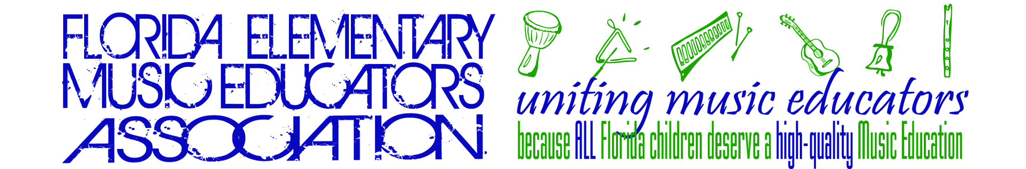2024

# FMEA Modern Band Regional Ensemble Music Teacher Audition Packet

## FEMEA Mission Statement

*The mission of the Florida Elementary Music Educators Association (FEMEA) is to unite and support music educators in order to provide a high-quality comprehensive music education for all children.*

## FEMEA Modern Band Regional Mission Statement and Goals

*The mission of the FMEA Modern Band Regional Ensemble is to provide an inclusive ensemble experience that respects, affirms, and protects the dignity and worth of all through a variety of styles of music.*

The goals of this ensemble are:

1. To provide elementary school students with an exciting, quality Modern Band experience with other students.
2. To encourage elementary school students to share artistry and grow as musicians.
3. To inspire elementary music educators to create a new set of standards of musical excellence in the public and private schools.
4. To develop pathways for underserved populations to participate.

Member teachers may [nominate up to 5 students,](https://forms.gle/VDzHF7rQSxXpQst96) ranked in order of their musical aptitude regardless of their instrument, for this Honor Ensemble. No more than 3 students(unless needed to complete the instrumentation) from one school will be selected. A screening video will be used to assist with music selection and rehearsal design. [Click here to upload the video](https://docs.google.com/forms/d/e/1FAIpQLSe3RuJMToOAGGdz6xzlkUvOSTcMM3zG1umH0B656RafhoY3hQ/viewform). Students will bring instruments/amps. Mics and extension cords will be provided.

# 2024 Fees

*All fees are nonrefundable.*

|  |  |  |
| --- | --- | --- |
| **Description** | **Amount** | **Deadline & Other Information** |
| **Participation Fee** | **$79.00**  per selected student | Fees for materials are payable online by credit card or via school/PTA check or money order made payable to FEMEA. You will receive additional information about where to mail fees if your student is selected to participate. |

*We are delighted that you are interested in participating in the FEMEA Regional Modern Band Ensemble. Students who are accepted for the FEMEA Regional Modern Band Ensemble will achieve a unique honor for themselves and their schools. FEMEA is committed to setting new standards of musical excellence in the public and private schools of Florida through an exciting, high-quality experience for students.*

## Nomination Video Information

### Teacher Directions

1. Set up a device to record audition (phones in landscape view)
2. Start the recording.
3. Memorization is not required.
4. Students' faces are allowed to be seen.

**Student Directions**

1. Students may play 1 or 2 of the instruments below. Separate instruments require separate videos.
   1. vocals
   2. keyboard
   3. bass guitar
   4. guitars
   5. drummer
   6. ukelele
2. For the video, the student should play along for 1:30 with the song "What About Us" by P!nk (Key of G major) *beginning when the student’s instrument begins in the track.*
3. The video should be one continuous recording.
   1. The recording should clearly show the student and their instrument in the frame.
   2. The students should be clearly heard over the backing track. Students using headphones to listen and play along is ideal.
4. Teacher turns off the camera and video ends.

## Nomination Video Submission

#### Recording Devices

* Computers, Phones, Tablets
* Windows Live Movie Maker, VideoPad, iMovie, etc.
* Hold your device sideways. *No vertical video!*

#### Upload/Data Transfer

* .mov or .mp4 format
* No bigger than 854 x 480 resolution. If 854 x 480 is not an option, choose 540p or the lowest one possible.