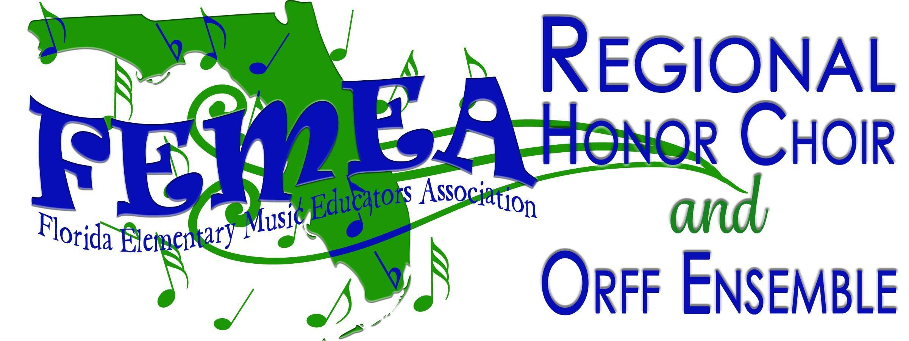

Dear Parent or Guardian:

Congratulations! Your child has been selected to participate in the 2023 Florida Elementary Music Educators Association Northern Regional Festival. This is quite an honor and we hope that it is an enjoyable and memorable experience for you and your child.

A “Reminder for Parents and Participants” list is included with this letter to help you make the necessary arrangements for your child. You may invite family and friends to the concert on Saturday evening. You will note in the information packet that you need to stay in or nearby the rehearsal with your child, throughout the day.

Please remember that children who are not in the FEMEA Northern Regional Festival are not permitted in the rehearsal area, and that non-participating school age children are not allowed in the Southeastern University campus buildings, except to attend the concert.

Please be sure to check the rehearsal schedule to plan meals and healthy snacks for your child. Please note that students must either bring lunch with them or must leave campus to find lunch at a dining option. You will only have 30 minutes for lunch, so consider picking up lunch early if you are not bringing your own. We want the students at their best for focus and performance. 100% attendance is required so have them in place and ready a minimum of ten minutes before the start time for each rehearsal.

If you have any questions, please do not hesitate to contact your music teacher.

Sincerely,

Joani Slawson
FEMEA Northern Regional Festival Coordinator
FEMEA Past-President

PARTICIPATION REQUIREMENTS

Participants must:
- be a 4th or 5th grade student, currently attending an elementary school and chosen by FEMEA through All-State auditions.
- be recommended by the music teacher and principal.
- agree to wear white blouse/button-down shirt, black dress pants or slacks with pockets (no jeans), and black low-heeled (no high heels) dress shoes for the concert performance.
- agree to participate in all rehearsals and the concert to be held in University of Florida in Gainesville on Saturday, October 28th, 2023.
- have already signed the Regional Participant’s Contract which specifies appropriate conference behavior.

Participant’s Parent/Guardian must:
- register and pay all lodging, food, and transportation costs.
- agree to serve as a chaperone for the child for the duration of the rehearsals and concert or designate an adult guardian (other than the music teacher) to serve as chaperone.
- agree to provide the child with a white blouse/button-down shirt, black dress pants/slacks with pockets (no jeans), and black low-heeled (no high heels) dress shoes for the concert performance for chorus/drums. Modern band will be your best rock clothes (skirts/shorts/dresses must be no more than 2 inches above the knee).
- have already signed the Regional Participant’s Contract.
- sign and return any forms that your child’s music teacher may require. This includes any permission forms required by your county.

REHEARSAL AND PERFORMANCE SCHEDULE
Students must participate in all rehearsals and the concert. Times are subject to change.

Northern Regional Student Schedule
8:30 - 9:00 am Registration
9:00 -10:00 am Rehearsal Session 1
10:00 - 10:15 am break
10:00 - 10:45 Rehearsal Session 2
10:45 - 11:00 am Break
11:00 - 11:45 am Rehearsal Session 4
11:45 - 12:25 pm Lunch Break
12:30 pm Rehearsal Session 4
1:15 - 1:30 pm Break
1:30 pm Rehearsal Session 5
2:30 pm Break
2:45 pm Dress Rehearsal on Stage
4:00 pm Break/Change/Snack
4:45 pm Line Up for Concert
5:00 pm Concert

PLEASE NOTE: A parent or guardian other than the music educator is required to accompany each child to the rehearsal site and to supervise the child at all non-rehearsal times, including breaks and meals. Breaks are built into the rehearsal schedule and will be posted outside each rehearsal room the day of the event.

REMINDERS FOR FEMEA NORTHERN REGIONAL PARENTS:

______Did you fill out a school or county form for out-of-county field trips which your music
teacher may have provided for you? Each county has different requirements, so this
form may not be required of you.
______Did you sign the Regional Participant’s Contract and return it to the music teacher
______Do you have hotel arrangements for at least one night, unless you are within
commuting distance to the rehearsal and performance site? You will need to be in Gainesville and at the University of Florida by 8:30 am on Saturday, October 28, 2023. Allow yourself up to 20 minutes for parking and walking, and registration.
______Have you made sure that your child has the required clothing to perform?
______Have you made arrangements to meet the music teacher in Gainesville before you come to
the FEMEA Northern Regional Festival registration area at the University of Florida?
______Have you made arrangements to either bring your student’s lunch, or go out to eat (on-
campus options list with map will be provided at the morning registration area)?
______Is there a designated adult (other than the music educator) to serve as a chaperone for
the child for the rehearsals and concert?
______Have you made arrangements for children in your party who are not FEMEA Northern Regional
Festival participants? It is a FEMEA policy that the only children allowed in the University of Florida buildings during rehearsals are the participants.

REMINDERS FOR FEMEA NORTHERN REGIONAL MUSICIANS:

_____Did you sign the Regional Participant’s Contract and return to your music teacher?
_____Do you have concert clothes: white blouse/button-down shirt, black dress pants or slacks with pockets (no
jeans) and black low-heeled dress shoes?
_____Are you ready to learn, memorize, and then perform all your music in just one day?
_____ Did you pack a pencil and water bottle for the rehearsals?

CHECKLIST FOR FEMEA NORTHERN REGIONAL TEACHERS

_____ Ensured all participating students parent/guardian has completed payment/registration?
_____ It is your responsibility to satisfy your county’s requirements for overnight/off-campus trips. You may need to fill out special forms or secure special permission. Contact your music supervisor or your principal for information.
_____ Notify Joani Slawson (see contact info below) about any students needing special accommodations.
_____ Ensure that parents know they must make their own hotel reservations, if needing to stay overnight.
_____ Remind your student(s) and parents to be aware of the schedule, to plan healthy eating, and not be late.
_____ Arrange a meeting place in Gainesville for you, your student(s), and their chaperone(s) as they may only
register with the teacher. The registration lines will be arranged alphabetically by the music teacher’s
last name.
_____ Bring the following information with you to Gainesville and keep it with you at all times:
1. The name of the hotel(s) housing your student(s), if applicable.
2. The parent names, home addresses, cell phone, and home phone numbers of your student(s).
_____ Provide the parents of your student(s) with your cell phone number.
_____ Plan on monitoring rehearsal times through-out the day and be available as needed to address any potential problems that may arise.
.

ALL STUDENTS, CHAPERONES, AND MUSIC TEACHERS MUST BE IN Gainesville at the UNIVERSITY ON SATURDAY, OCTOBER 28, 2023 FROM 8:30 AM UNTIL THE END OF PERFORMANCE AT APPROX. 6:00 PM.

Music teachers MUST check their students in at the rehearsal site on Saturday before 9:00 am. If you know that you cannot be present at registration, please do not send your students. It is confusing and disturbing for children and parents when the teacher is not present to answer questions and assist the students in starting rehearsals. If you have a last-minute emergency, it is your responsibility to contact another teacher who will be attending FEMEA Northern Regional and make arrangements for that teacher to be responsible for your children. Teachers who fail to do this will not be allowed to participate in future FEMEA Regional and/or FMEA All-State ensembles and the principal will receive a letter describing the situation.

As soon as you know that any of your students will be unable to participate in FEMEA Northern Regional Festival, it is your responsibility to contact the coordinator, Joani Slawson, immediately at joani@femea.flmusiced.org or 321 432-2770.

