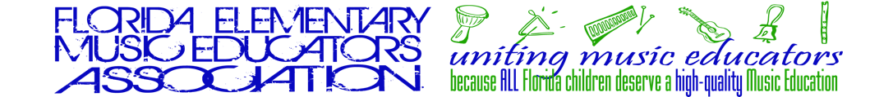

Dear Parent or Guardian:

The FMEA All-State Orff Ensemble will perform at the January 2025 Florida Music Education Association (FMEA) Professional Development Conference in Tampa. Only the finest fourth and fifth grade musicians in the state are asked to audition for this ensemble, and your child is so honored. We are excited this year to have internationally acclaimed conductors, Evan Billings and Jennifer Prestridge.

Your child’s music educator will help to make a video recording. There is a processing fee that must be sent with the paperwork submitted by September 12, 2024. Results of the auditions will be available for your music educator on October 11, 2024. The decisions of the judges are final, and auditions will not be re-heard. If your child is selected, there will be an FEMEA (Florida Elementary Music Educators Association) materials fee of $55 that will cover music, materials, clinician’s fees and practice recordings. Additional FMEA Conference fees will be required. Check with your music teacher for details. All fees are non-refundable.

If selected, your child’s name and school will be published on the FEMEA website. You will need to travel to Tampa on Thursday, January 10, 2025 allowing time to park and walk to the Tampa Convention Center. Check-in begins at 10:15 am and ends at 11:00 am. You will need to make arrangements to stay for one night, unless you are within commuting distance to the rehearsal and performance site. Hotel and meals are the responsibility of the parent as needed. It is an All-State policy that children who are not in the ensemble are not allowed in the rehearsals and Tampa Convention Center does not permit school age children in the Convention Center except to attend the concert. Rehearsals are Thursday and Friday, January 9th and 10th, and the concert will be held on Friday afternoon. A parent or adult guardian chaperone (other than the music educator) must accompany the student at all times. Housing information will be available for your music teacher in early fall. Tickets for family and friends, other than the student’s chaperone, will be available.

Thank you for your interest in your child’s musical growth and artistry.

Sincerely,

YOUR NAME
Music Teacher

